**Project Name:** Covid19 Prediction (Chest Xray)

**Github Link:** https://github.com/projectsforstudents2022/Covid19_Prediction-Chest_Xray-.git

**Why was this project created?**

Millions of people have already died as a result of the COVID-19 epidemic, which has disrupted people's everyday lives and destroyed several businesses throughout the world. In order to combat this condition, it is crucial to quickly and affordably test the afflicted people. Due to the endless concern about sickness and the lack of effective treatments, every nation is facing difficult challenges when it comes to safeguarding the welfare of its citizens.

**What problem is it solving?**

Due to the COVID-19 epidemic, the whole globe is currently experiencing a health catastrophe that is unprecedented in its sort. Researchers are concerned about finding ways to stop the pandemic epidemic and preserve lives as the coronavirus continues to spread. We create a deep learning system to analyze chest X-ray pictures, extract characteristics, and identify COVID-19. It was built by assembling COVID-19 and standard chest X-ray pictures from several open datasets. In order to artificially produce a huge number of chest X-ray pictures, we used data augmentation techniques.

**Entire explanation of project**

* **PROPOSED APPROACH**

We train, validate, and test three well-known pre-trained deep learning architectures in this work to categorize chest radiography pictures into COVID-19 and non-COVID-19 chest X-ray classes. As preparing the dataset is the initial step in using deep learning, we begin there. We examine the lung health of a patient using chest X-ray imaging, whereas COVID-19 focuses on the epithelial cells lining our airways. The model performs better with additional data, however as COVID-19 is still a recently developing illness, there isn't yet a suitable dataset that is openly accessible. Because data augmentation is a very effective method for creating a huge dataset artificially, we must employ it.

It would be impossible to create a CNN model from scratch to automatically detect COVID-19 from X-ray pictures due to the dearth of free COVID-19 radiography data. We use a well-known technique called "transfer learning" to manage this issue and enhance three well-known pre-trained models on the pre-prepared data set. The pre-trained model is used as a feature extractor; in other words, its weights are not appropriate for new tasks since the extracted features are then fed into a brand-new classifier that has been trained from scratch. In this procedure, new data will be sent through the previously trained network's convolutional basis, and a new classifier will be trained using the results.

Algorithm for creating next word prediction model :

**Step 1:** Import Libraries & Load Dataset

**Step 2:** Data Augmentation

**Step 3:** Image Enhancement

**Step 4:** Build Neural Network

**Step 5:** Train Model

**Step 6:** Testing & Visualization

* **DATA FLOW DIAGRAM**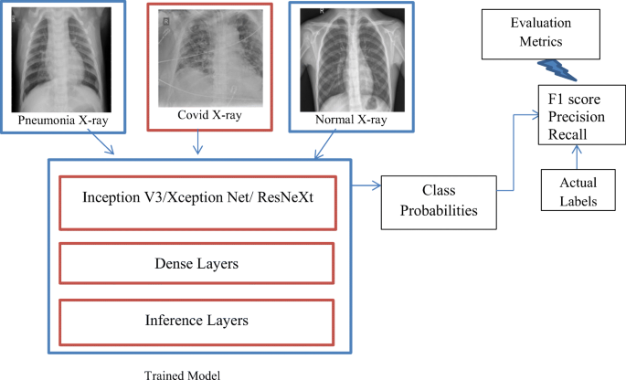
* **RESULT**

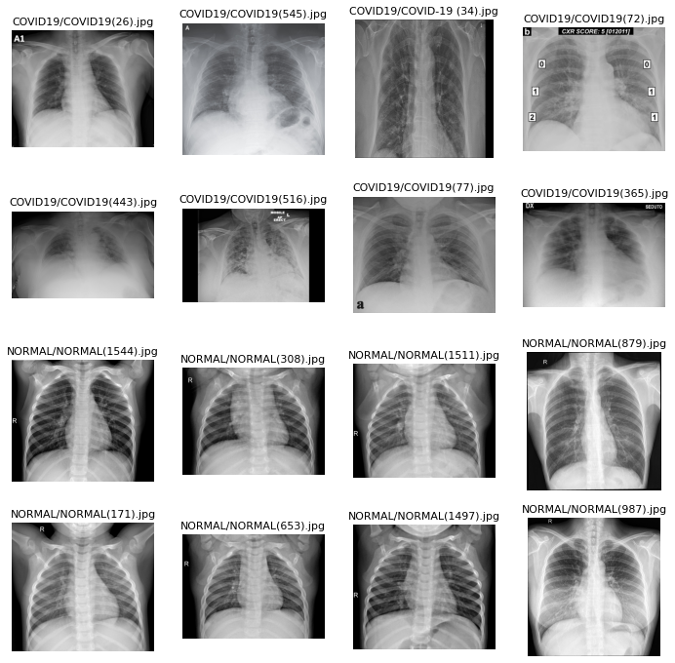

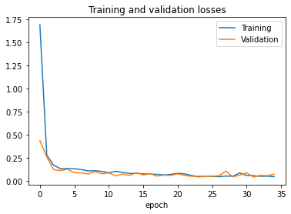

* **CONCLUSION**

To stop the new coronavirus from infecting other people, it is crucial to diagnose the virus as soon as possible. Along with this study, we developed a deep transfer learning-based system that combines chest X-ray pictures of patients with COVID-19 and those without the condition to automatically identify the illness. The recommended categorization model for COVID-19 detection has a greater than 94% accuracy rate. Our study's findings indicate that, given its strong overall performance, doctors and other health professionals should naturally rely on it to aid in clinical decision-making. This work has a thorough grasp of the application of deep transfer learning algorithms to find COVID-19 as soon as feasible.